
Introduction to DOSBox
Lab 10

Computer Organization and Assembly Language

Student Name | Muhammad Hassan Khalid
Registration # | 21L-5692
Instructor | Hazoor Ahmad
Class | CS3
Section | A1, A2, D1, D2
Semester | Fall 2022

Fast School of Computing
FAST-NU, Lahore, Pakistan

Activity 1

Assembly Language Code
[org 0x0100]
jmp start
message1: db 'Hi! I am Muhammad Hassan Khalid',0
message2: db 'I am Sad',0
message3: db 'Because I study at FAST',0
message4: db 'My Roll Number is 21L-5692',0

clrscr:
push es
push ax
push cx
push di
mov ax, 0xb800
mov es, ax
xor di, di
mov ax, 0x0720
mov cx, 2000
cld
rep stosw
pop di
pop cx
pop ax
pop es
ret
strlen:
push bp
mov bp, sp
push es
push cx
push di
les di, [bp+4]
mov cx, 0xffff
xor al, al
repne scasb
mov ax, 0xffff
sub ax, cx
dec ax
pop di
pop cx
pop es

pop bp
ret 4
printstr:
push bp
mov bp, sp
push es
push ax
push cx
push si
push di
push ds
mov ax, [bp+4]
push ax
call strlen
cmp ax, 0
jz exit
mov cx, ax
mov ax, 0xb800
mov es, ax
mov al, 80
mul byte [bp+8]
add ax, [bp+10]
shl ax, 1
mov di, ax
mov si, [bp+4]
mov ah, [bp+6]
cld
nextchar:
lodsb
stosw
loop nextchar
exit:
pop di
pop si
pop cx
pop ax
pop es
pop bp

ret 8
start:
call clrscr

mov ah, 0
INT 0x16

mov ax, 30
push ax
mov ax, 10
push ax
mov ax, 0x71
push ax
mov ax, message1
push ax
call printstr

mov ah, 0
INT 0x16

mov ax, 30
push ax
mov ax, 11
push ax
mov ax, 0x71
push ax
mov ax, message2
push ax
call printstr

mov ah, 0
INT 0x16

mov ax, 30
push ax
mov ax, 12
push ax
mov ax, 0x71
push ax
mov ax, message3
push ax
call printstr

mov ah, 0
INT 0x16

mov ax, 30
push ax
mov ax, 13
push ax
mov ax, 0x71
push ax
mov ax, message4
push ax
call printstr

mov ax, 0x4c00
int 0x21

Debugging Screenshots
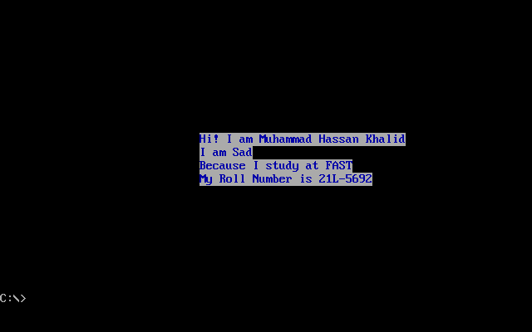

Activity 2

Assembly Language Code
[org 0x0100]
jmp code
w equ 70 ; width offset
x equ 50 ; starting x coordinate of line
y equ 100 ; starting y coordinate of line
c equ 60 ; color
code: mov ah, 0
mov al, 13h
int 10h
; draw diagonal 11:
mov cx, x
mov dx, y
mov al, c
u1: inc dx
mov ah, 0ch ; put pixel
int 10h
inc cx
cmp cx, x+w
jbe u1
;wait for keypress
mov ah,00
int 16h
; draw diagonal 12:
mov cx, x
mov dx, y
mov al, c
u11: dec dx
mov ah, 0ch ; put pixel
int 10h
inc cx
cmp cx, x+w
jbe u11
;wait for keypress
mov ah,00
int 16h
; draw diagonal 13:
mov cx, x+w
mov dx, y-w
mov al, c
u13: inc cx
mov ah, 0ch ; put pixel
int 10h
inc dx
cmp dx, y
jbe u13
;wait for keypress
mov ah,00
int 16h
; draw diagonal 14:
mov cx, x+w+w
mov dx, y
mov al, c
u12: dec cx
mov ah, 0ch ; put pixel
int 10h

inc dx
cmp dx, y+w
jbe u12
;wait for keypress
mov ah,00
int 16h
mov ah,00
int 16h
mov ax, 0x4c00
int 21h

Debugging Screenshots


